目录
4. Managing Meal Plans 1
Purpose 1
4.1 Accessing the Meal Planner 1
4.2 Personalizing and Generating Your Plan 2
4.3 Navigating the Weekly Overview & Sidebar Controls 3
4.4 Viewing Daily Details and Recipe Instructions 5
4.5 Customizing Individual Meals (Swap & Alternatives) 7
💡 System Note on Recipe Matching: 10
4.6 Homepage Tracking and Daily Progress 10

4. Managing Meal Plans

Purpose

This section explains how to use the MyDiet recommendation engine to generate, customize, and manage your weekly nutritional meal plans. The system uses strict nutritional science algorithms (e.g. the Mifflin-St Jeor formula) to calculate your precise Basal Metabolic Rate (BMR) and match you with the best recipes from a database of over 165,000 options.

4.1 Accessing the Meal Planner
Assuming you are already logged in to your account, click the Plan tab on the top navigation bar from your Dashboard to access the meal planning module.

4.2 Personalizing and Generating Your Plan
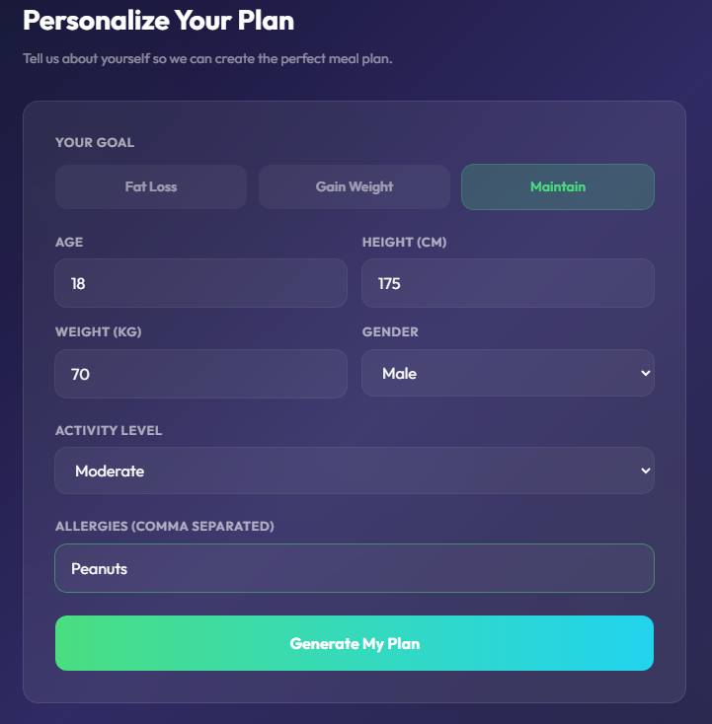
To ensure the algorithm calculates your target calories and macronutrients accurately, you must provide precise physical data.
Steps:
- Select your Goal: Choose between Fat Loss, Gain Weight, or Maintain.
- Enter your physical stats:
  - Enter your Age.
  - Enter your Height in CM.
  - Enter your Weight in KG.
- Select your Gender and Activity Level: Choose your activity frequency (from Sedentary to Very Active) from the dropdown menus.
- Enter Allergies: Type any ingredients you must avoid.
  - Important: You must use commas to separate multiple allergies (e.g., Peanuts, Shellfish) to ensure the system filters them correctly.
- Click the Generate My Plan button.

4.3 Navigating the Weekly Overview & Sidebar Controls
Once generated, you will see the Weekly Meal Plan view, displaying your meals from Monday to Sunday. To ensure variety, the algorithm automatically excludes any recipes you have already been assigned within the 7-day period.

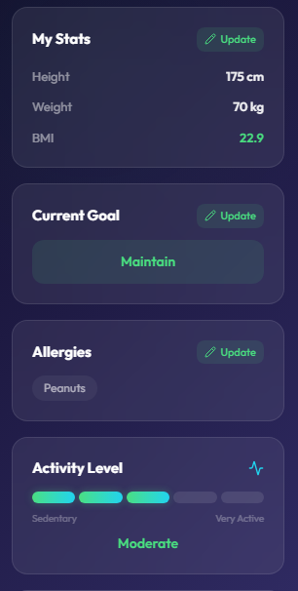
4.3.1 Making Quick Updates
If your stats or goals change mid-week, use the left sidebar:
- Click Update next to My Stats, Current Goal, or Allergies.
- Enter your new data and click Save.

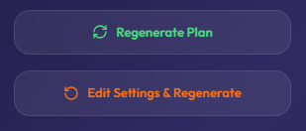
4.3.2 Regenerating Options
- Regenerate Plan: Click this to keep your current stats but trigger the algorithm to search the database and score a completely new set of meals for the week.
- Edit Settings & Regenerate: Click this to return to the initial setup form for a complete profile overhaul.

4.4 Viewing Daily Details and Recipe Instructions
Steps:
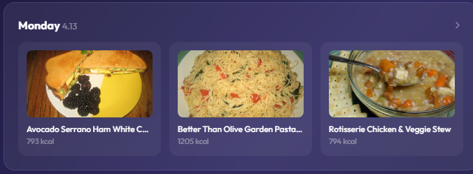
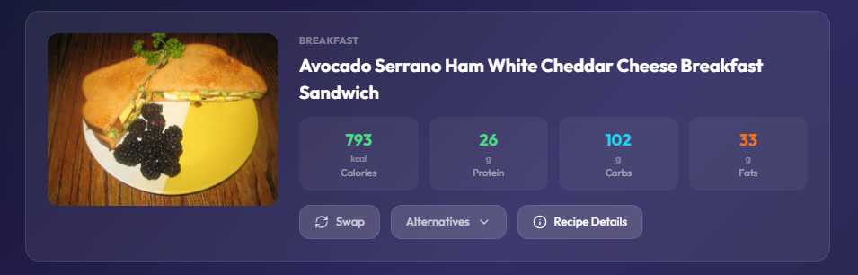
- Click on a specific day (e.g., Monday) in the Weekly view.
- Review the precise macro breakdown (Calories, Protein, Carbs, Fats) for Breakfast, Lunch, and Dinner.

- Click the Recipe Details button on any meal card.
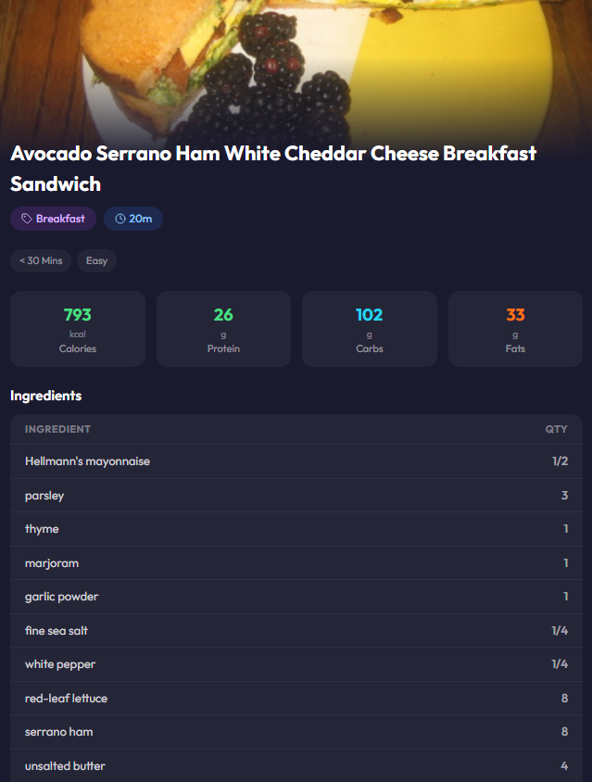
- A popup window will display:
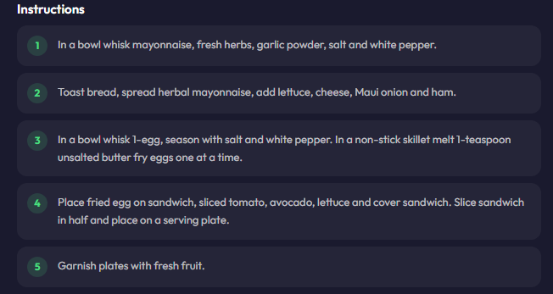
  - A detailed Ingredients list with required quantities.
  - Step-by-step cooking Instructions.

4.5 Customizing Individual Meals (Swap & Alternatives)
If you dislike a specific meal, you can replace it without disrupting the rest of your week.
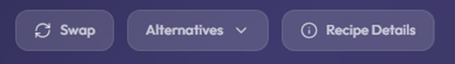
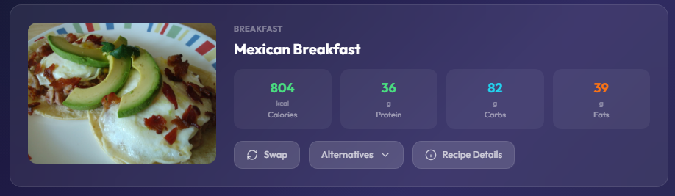
- o auto-replace a meal (Swap):
Click the Swap button. The system will trigger the pickMealSlot function, automatically replacing the meal with the next highest-scoring recipe that perfectly matches your daily macro targets.
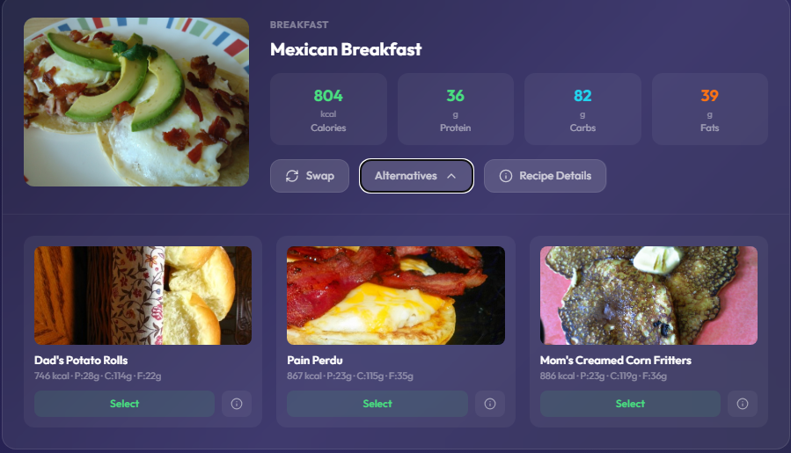

- To manually choose a backup (Alternatives):
  - Click the Alternatives dropdown on the meal card. The system displays the top 3 alternative recipes that scored closest to your macro targets.

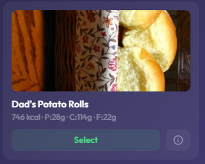
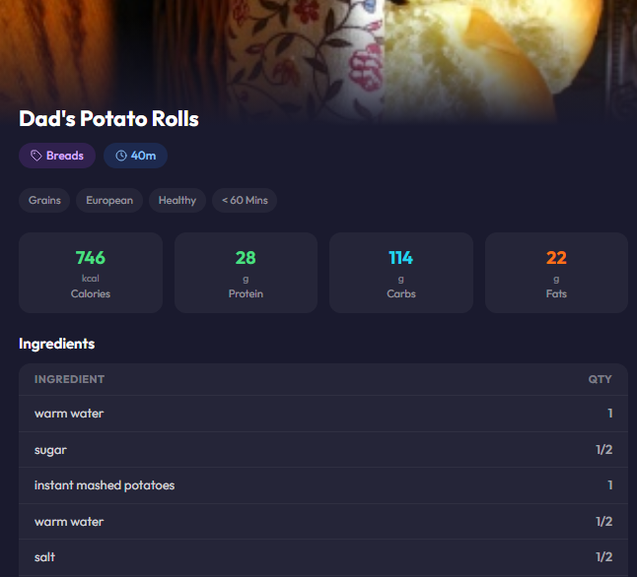


  - Click the (i) icon next to an alternative to view its ingredients and cooking steps before deciding
.
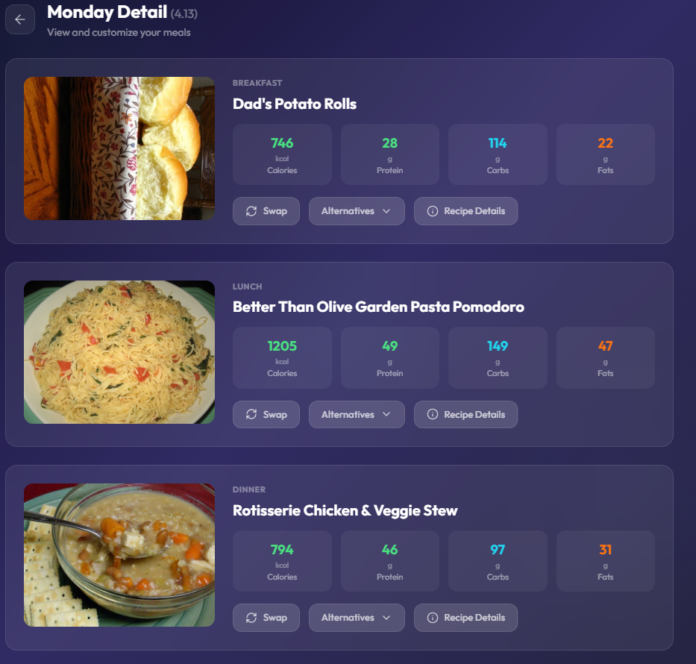
  - Click Select on your preferred alternative. The system will instantly update your daily plan.

💡 System Note on Recipe Matching:
During generation or swapping, recipes are filtered to fall within ±15% of your calorie target (expanding to ±25% if necessary). The system then uses a Least-Squares scoring method to find meals that perfectly balance your required protein, carbs, and fats.

4.6 Homepage Tracking and Daily Progress
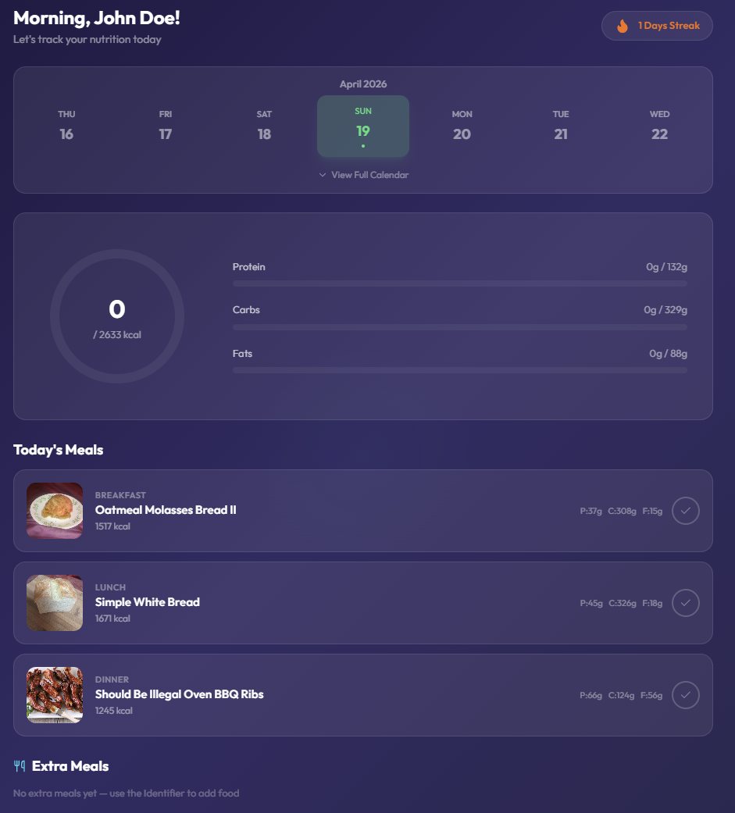
Once your plan is generated, the Homepage serves as your daily command center for tracking nutrition and maintaining consistency.

Features and Operations:
- View Daily Status: On the homepage, you can see your total calorie goal for the day and the current progress of your macronutrients (Protein, Carbs, and Fats).
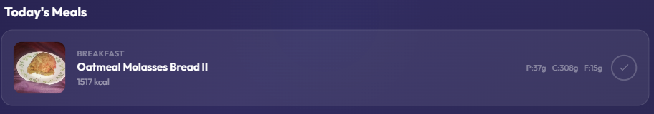
- Log Your Meals: Under the Today's Meals section, click the Checkmark (✓) icon on the right side of any meal card once you have finished eating.
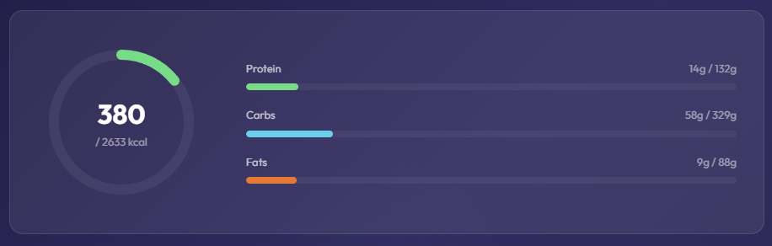
- Dynamic Feedback: After checking a meal, the Nutritional Ring and progress bars will automatically fill up, showing how many calories you have consumed versus your daily limit.
- Daily Streak: Click the Days Streak (Flame icon) in the top right corner of the screen to record your daily check-in and maintain your healthy eating streak.

